# Project Title: Flower recognition

## Group members: Rimple Poonia Dabas, Sakshi Dalal, Sweta Joshi

## Aim: Flask based App to identify type of flower from an uploaded image

### Data Collection:

* Google Images: Web scraping
* Flickr: API
* Pixabay: API

### Data cleaning

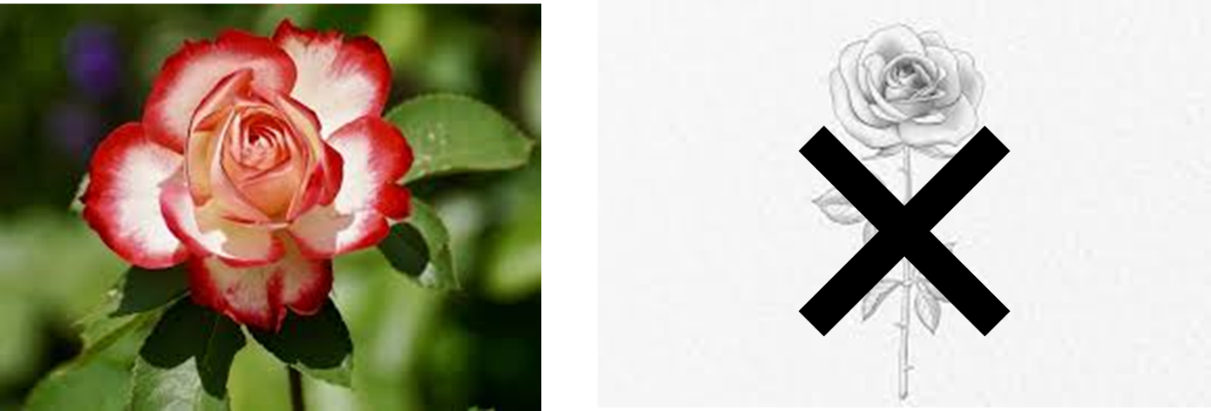 Combining images and getting rid of junk images (manually)

### Model

### Flask app

### JavaScript CSS and HTML

